Graphics and rendering

http://www.arcsynthesis.org/gltut/Basics/Intro%20Graphics%20and%20Rendering.html

The process used by real-time graphics hardware, such as that found in your computer, involves a very great deal of fakery. This process is called rasterization, and a rendering system that uses rasterization is called a rasterizer.

triangles that are sent to OpenGL where they are rendered using a hardware accelerator called a rasterizer

As polygons, triangles are always convex, and therefore filling rules are easy to devise.

Concave polygons can always be broken down into two or more triangles

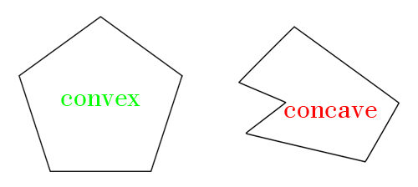

In hardware, the “triangle rasterizer” is a block that tells you what (sub-)pixels a triangle covers;

The fundamental unit of rendering in OpenGL is the primitive

primitives: points, lines triangles

OpenGL support many types of primitives, but the three basic renderable primitive types are points, lines, and triangles.

Applications will normally break complex surfaces into a very large number of traingles and send them to OpenGL

